**L2 MAC Flooding & ARP Spoofing**

**Introduction**

This sub task introduces the learner to the practical knowledge in using MAC Flooding to sniff traffic and ARP Cache Poisoning to manipulate network traffic as a MITM (Man in The Middle).

***Activities***

***Task 1: Getting Started***

This section outlines objectives such as the social media site to be attacked using a virtual machine, the location of the site.

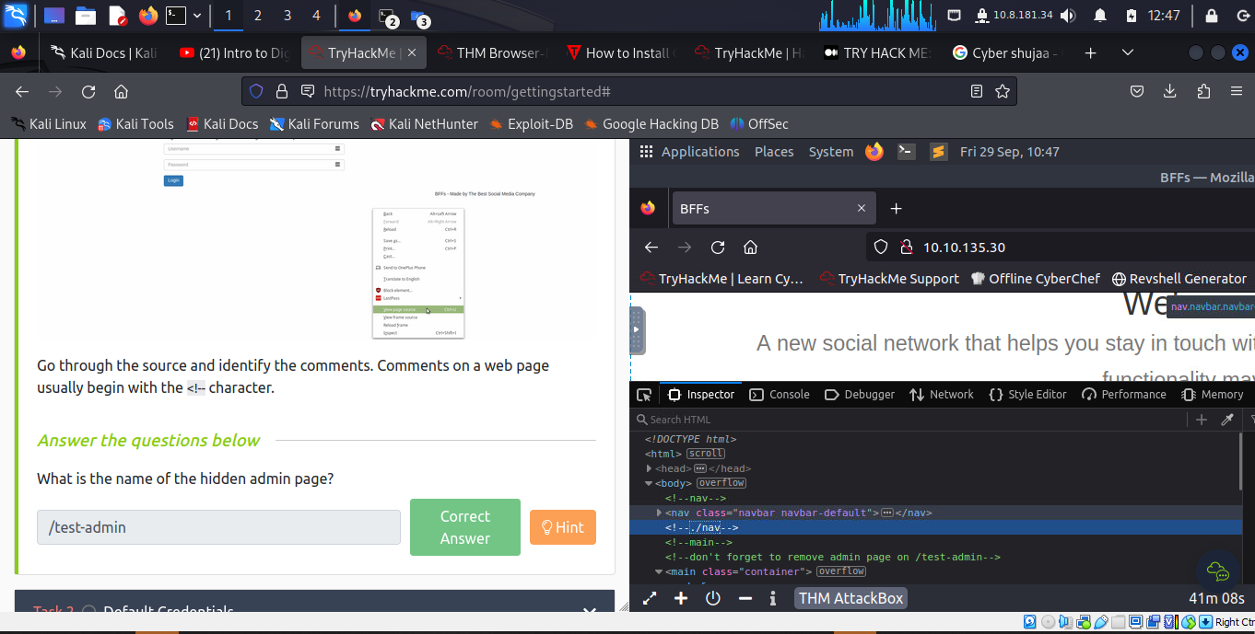

***Task 2: Initial Access***

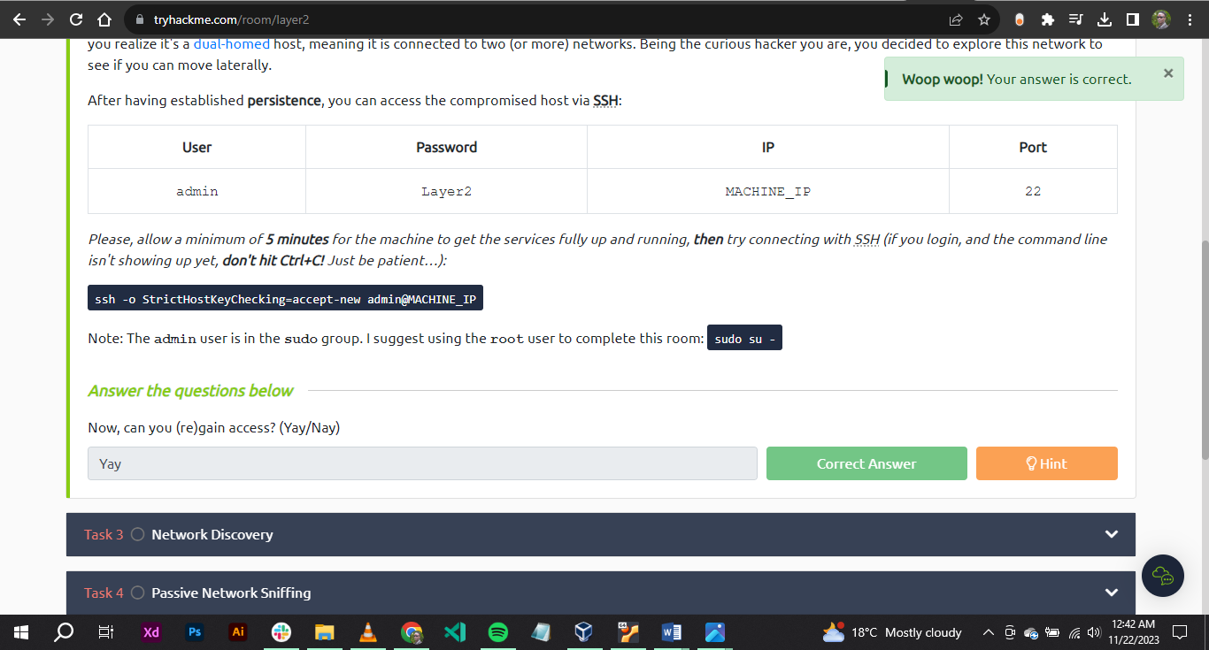

***Task 3: Network Discovery***

The network of interest is connected with Ethernet adapter **eth1**.

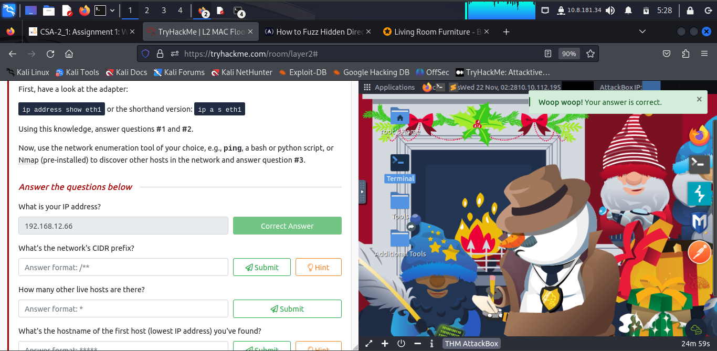

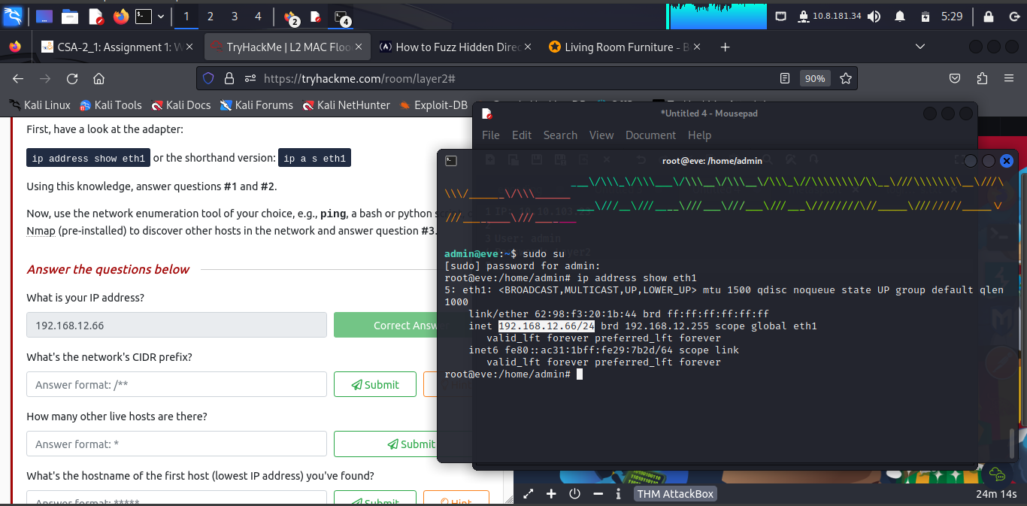

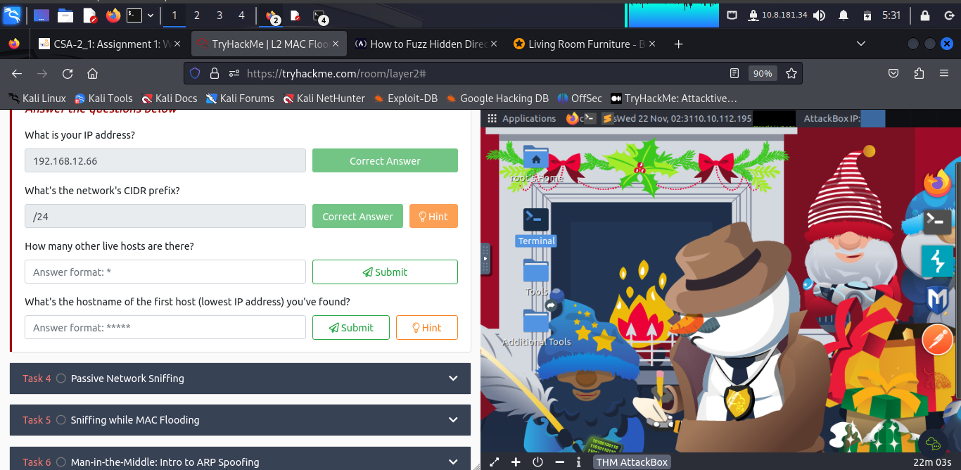

The network's CIDR prefix is **/24**

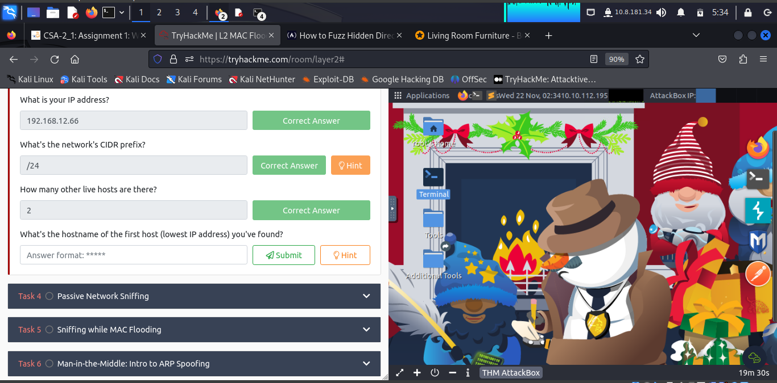

There are other **2** live hosts.

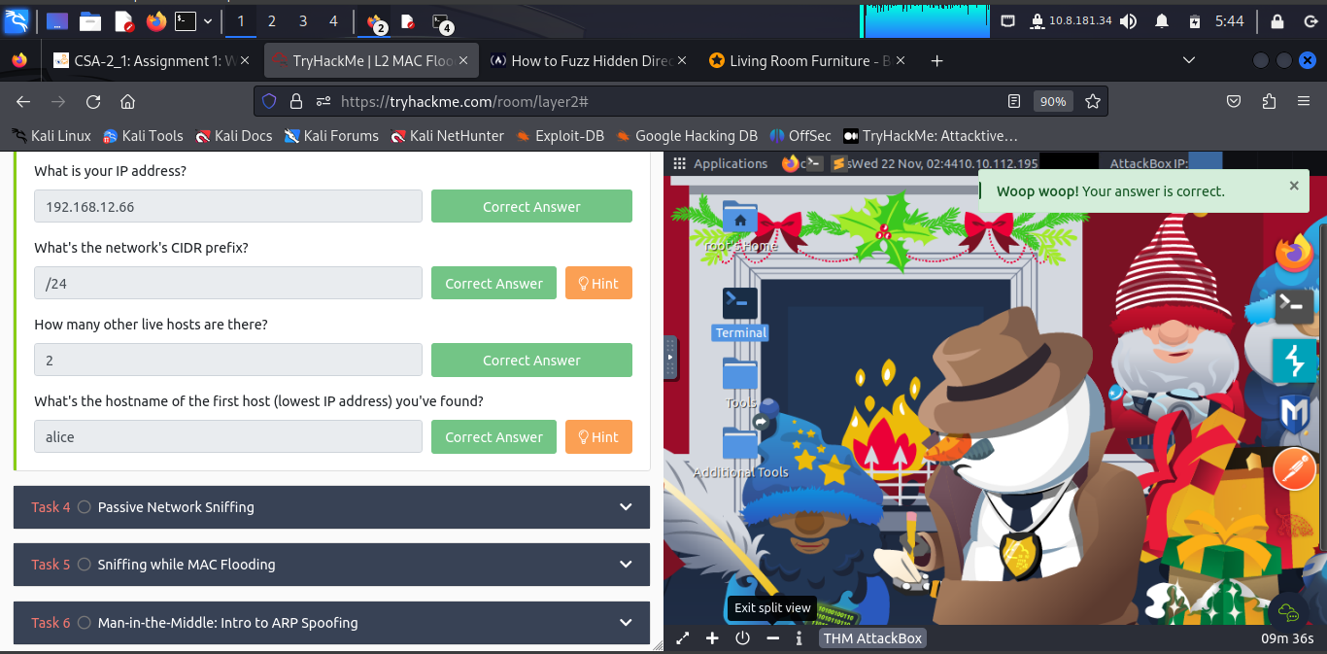

To find hostname(s) the learner first run **nmap –n 192.168.12.0/24**. Then **cat /etc/hosts**

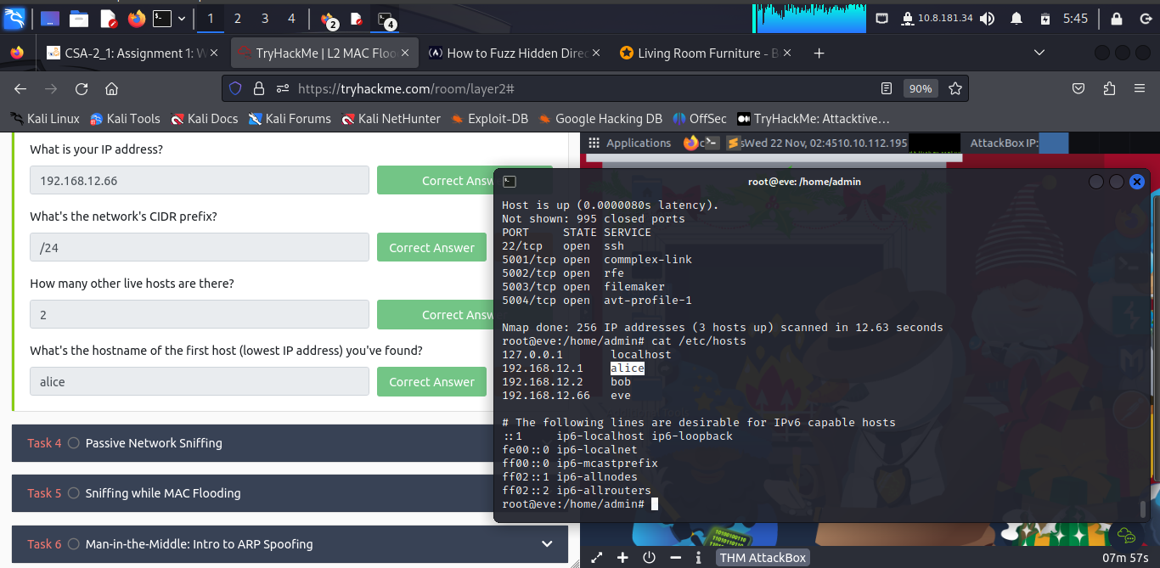

***Task 4: Passive Network Sniffing***

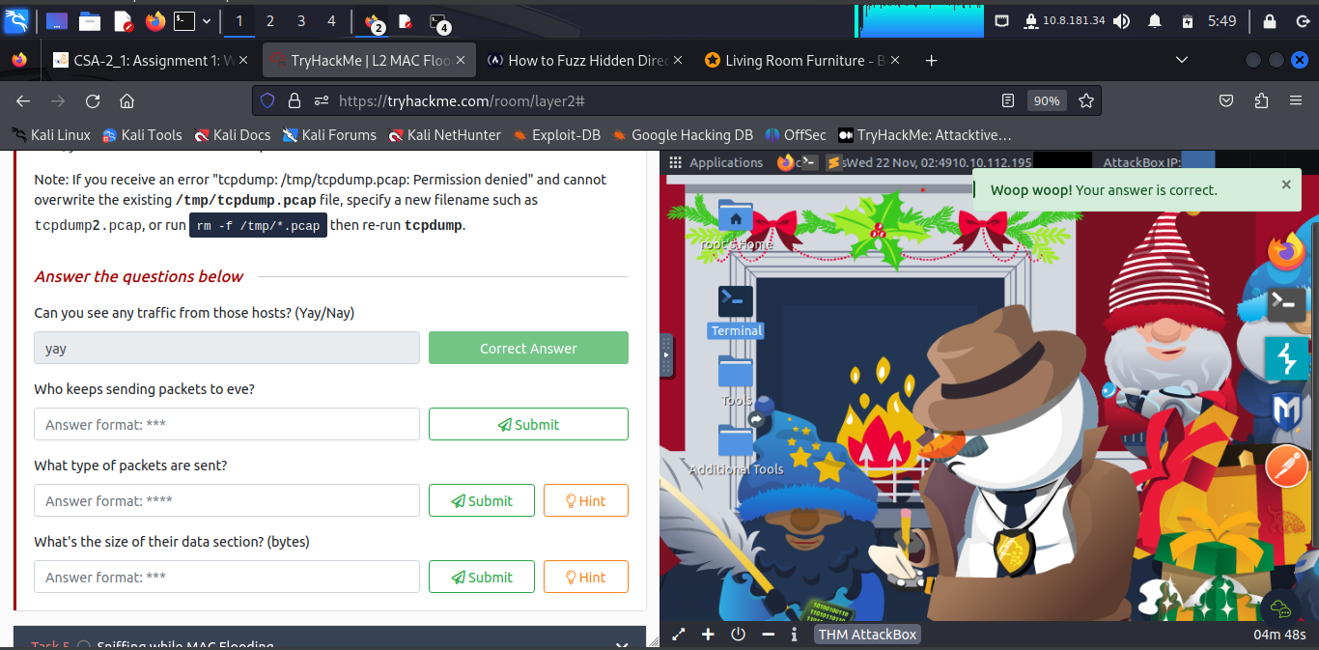

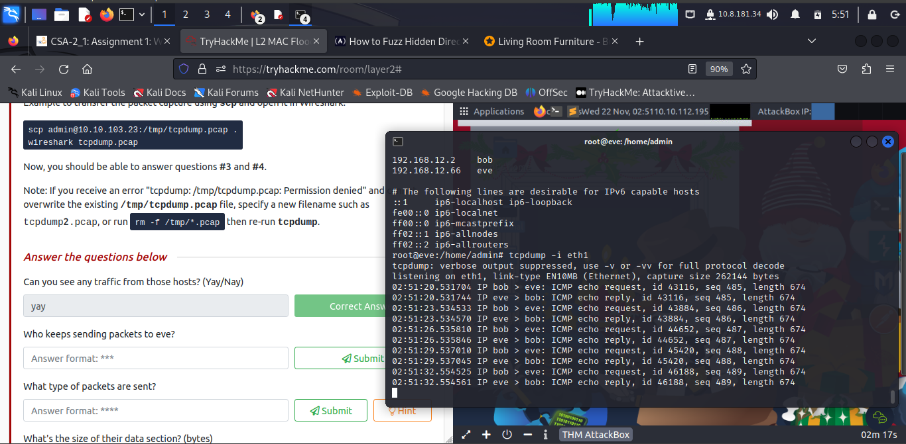

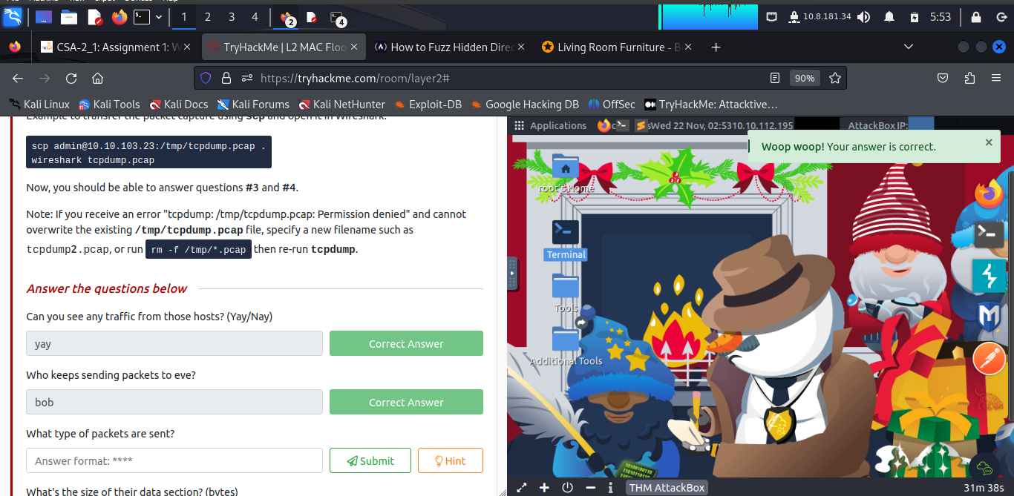

**Bob** keeps sending packets to eve.

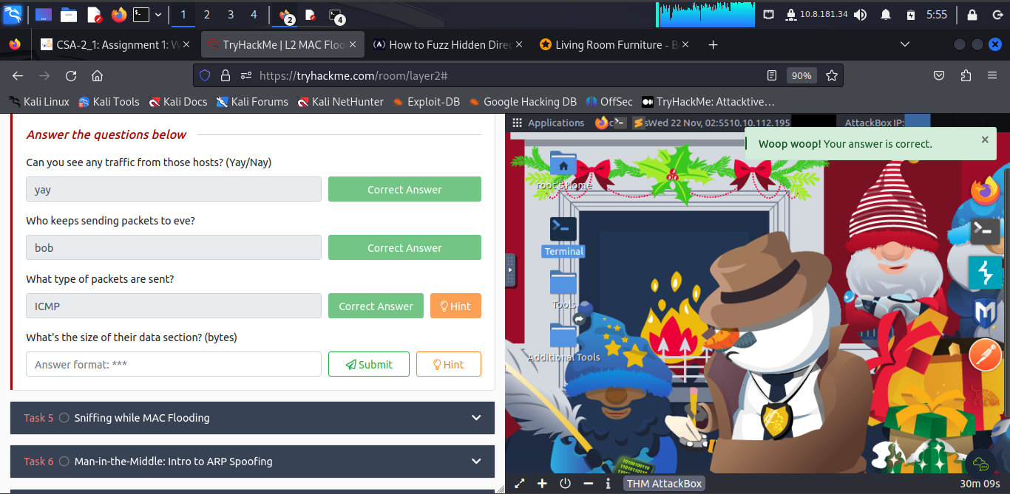

The type of packets being sent are **ICMP**

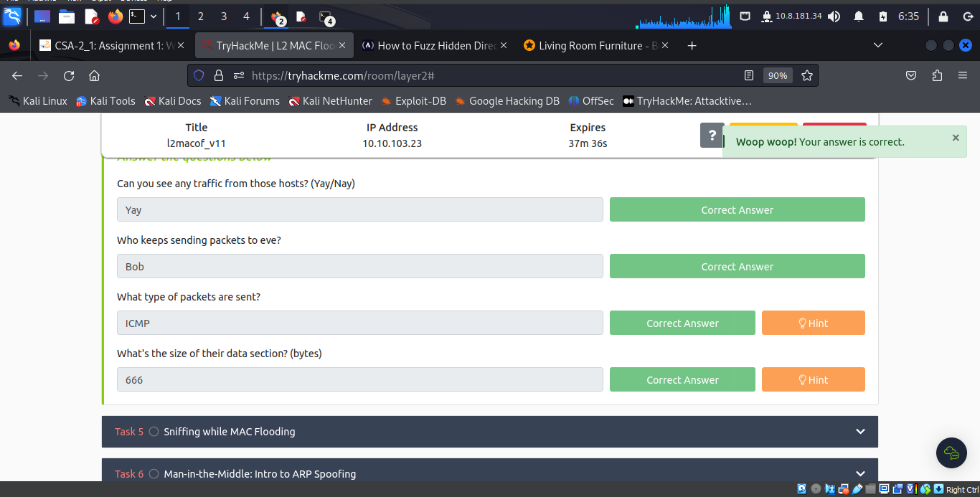

***Task 5: Sniffing while MAC Flooding***

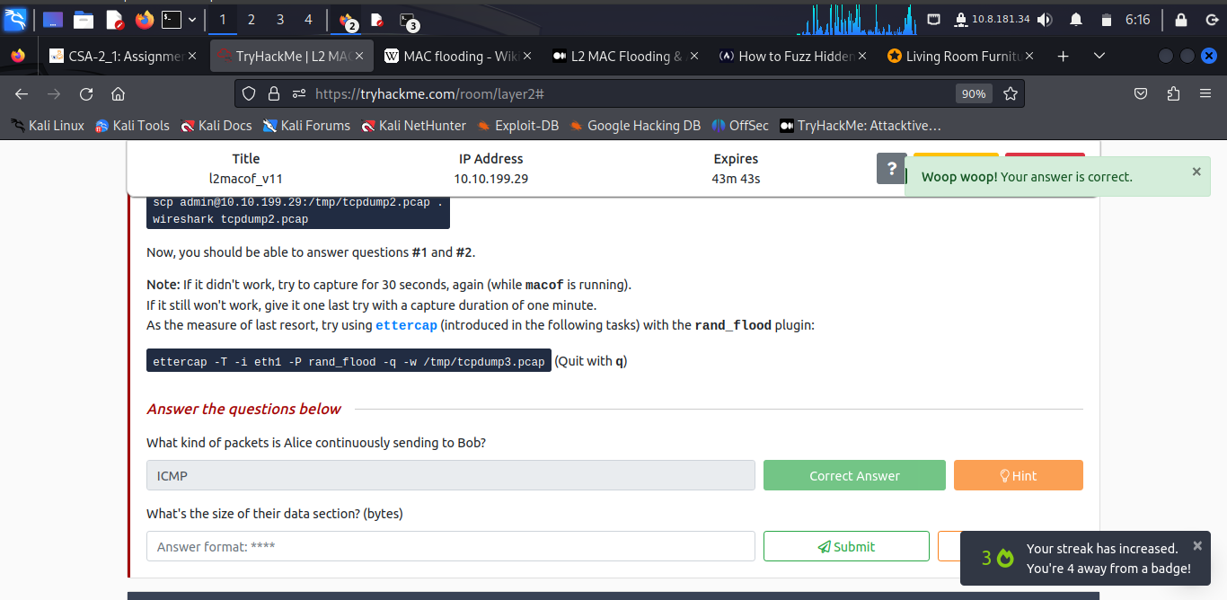

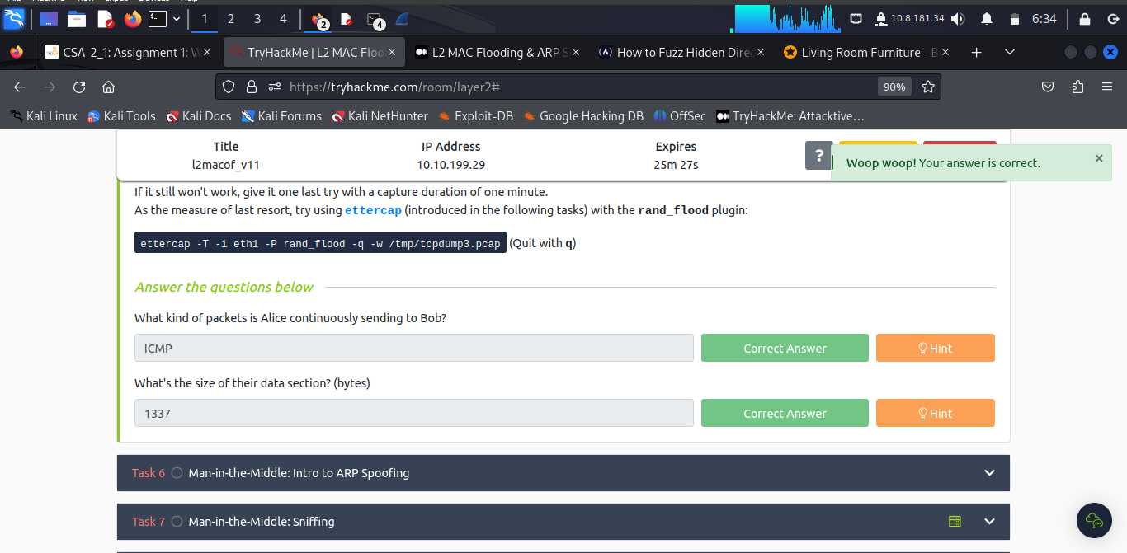

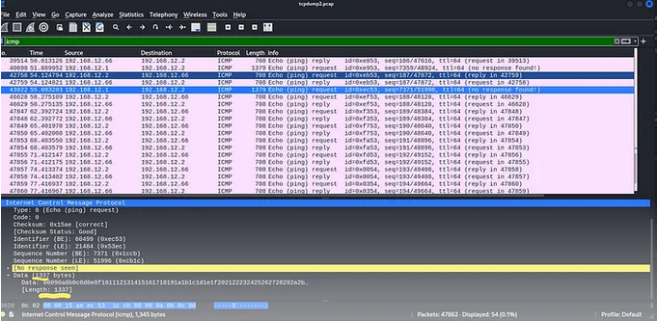

***Task 6: Man-in-the-Middle: Intro to ARP Spoofing***

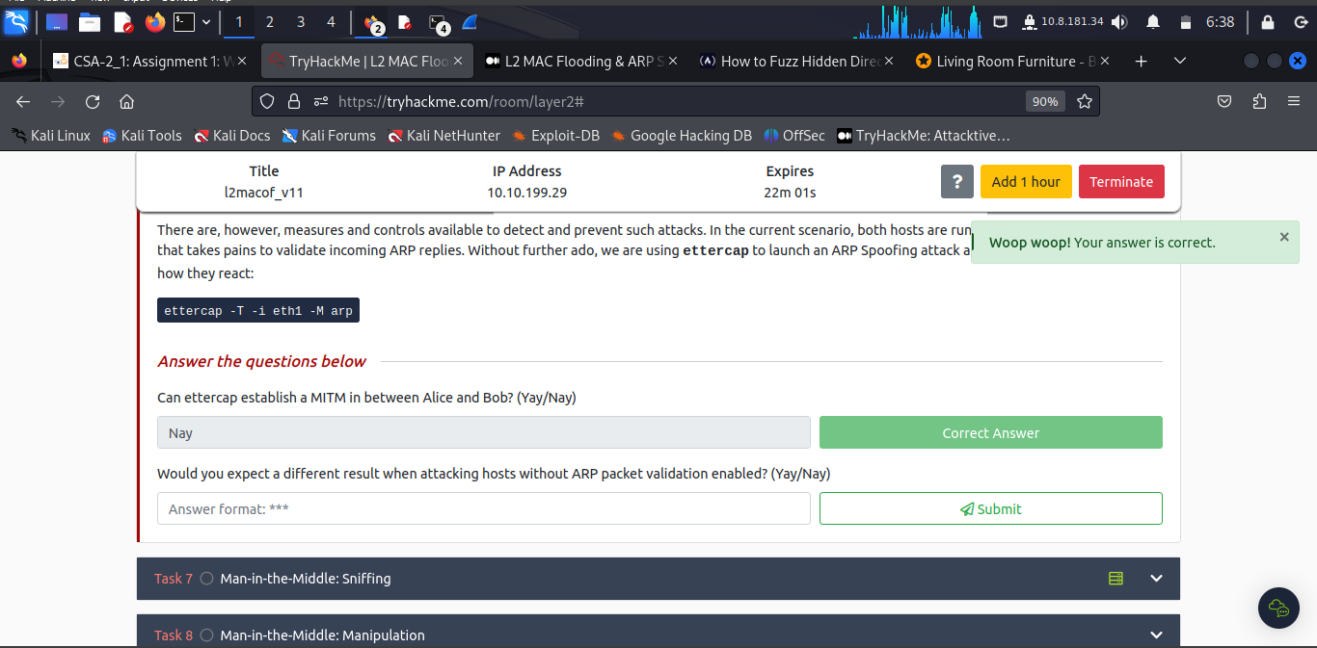

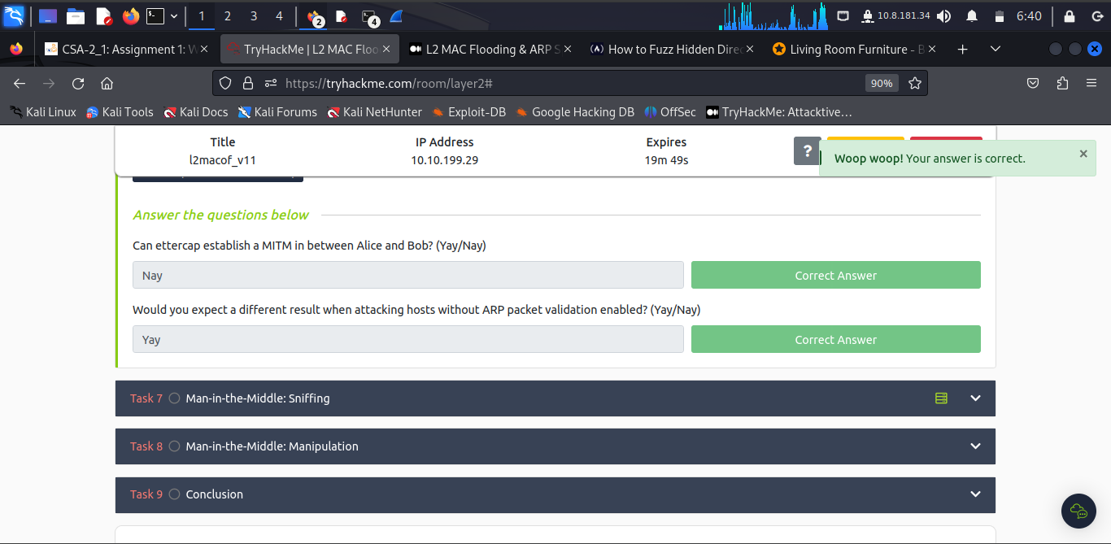

***Task 7: Man-in-the-Middle: Sniffing***

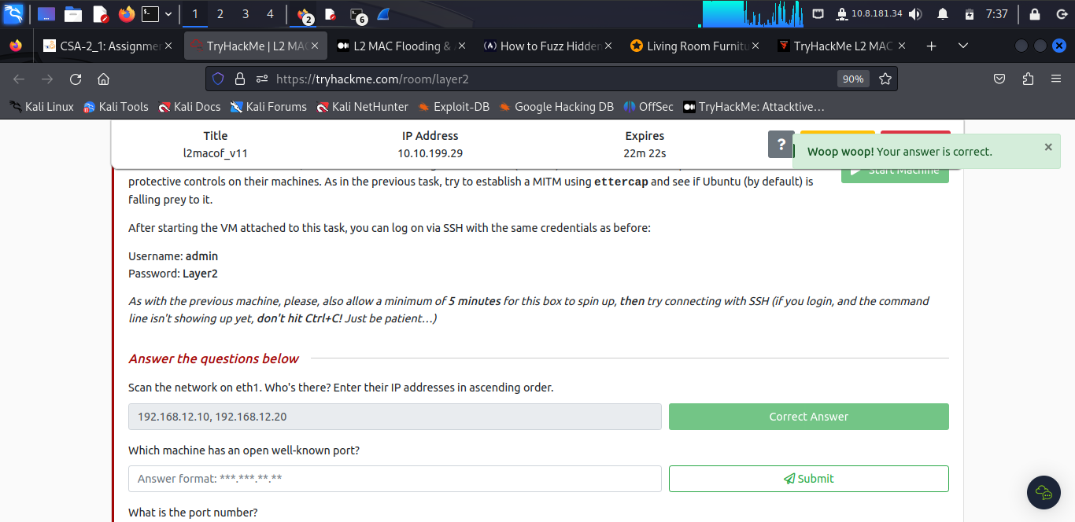

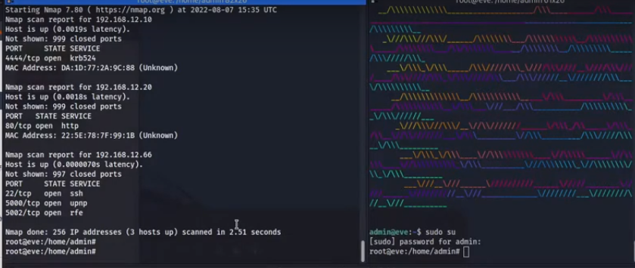

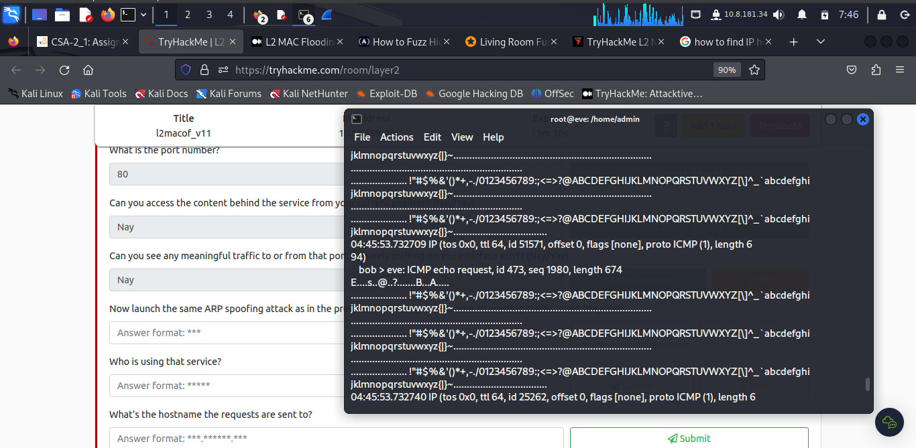

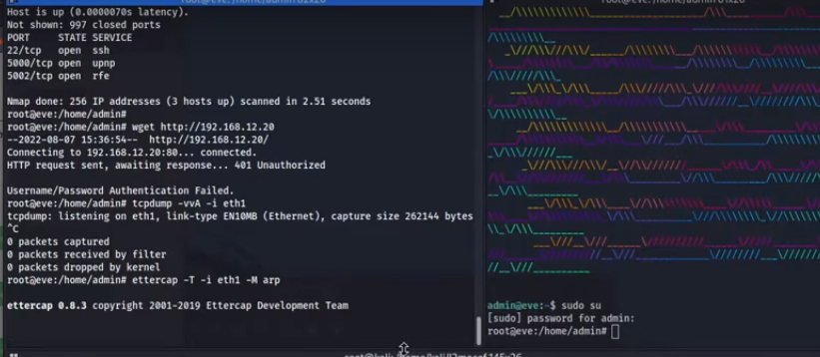

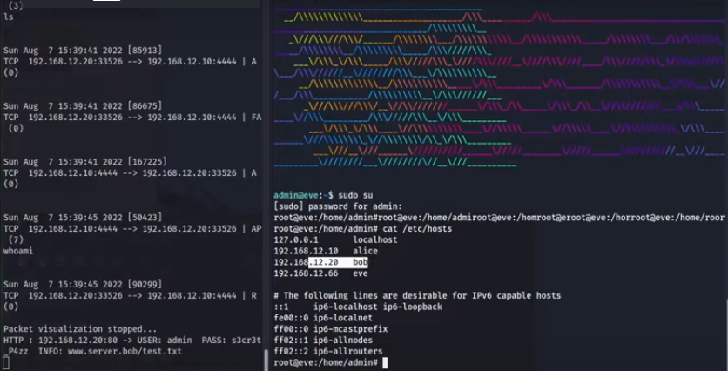

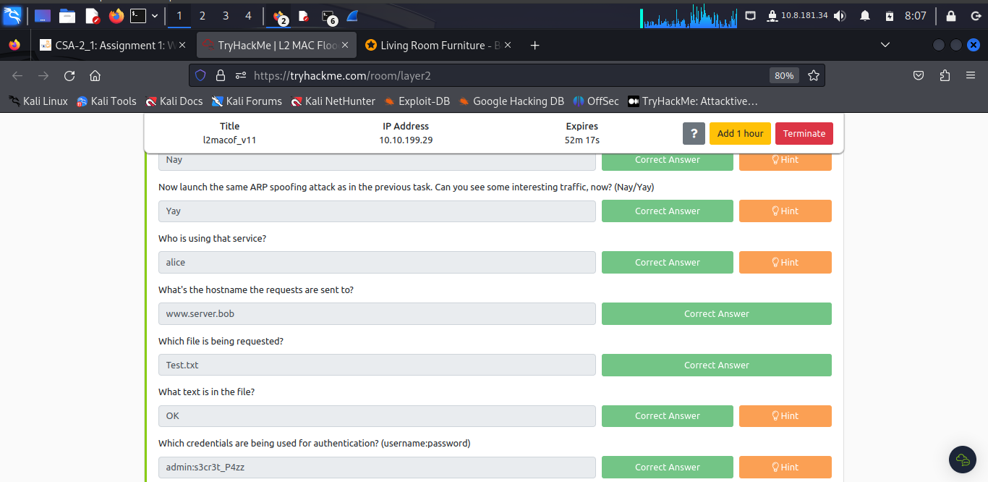

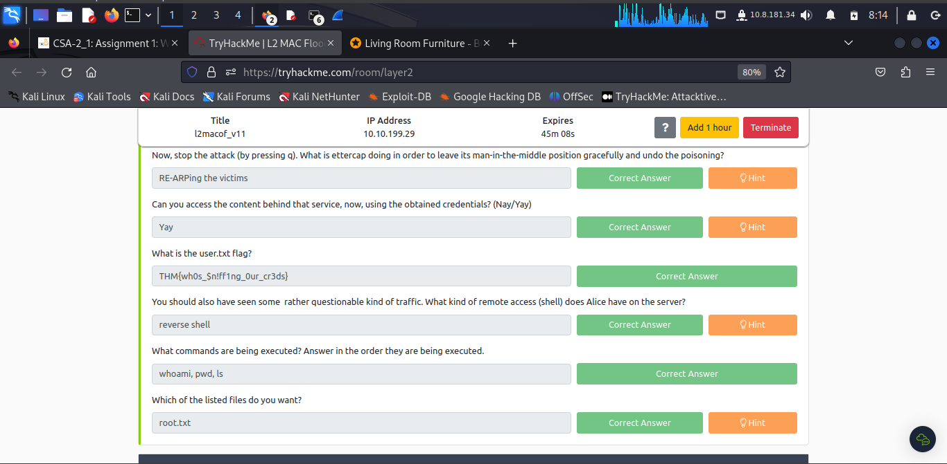

***Task 8: Man-in-the-Middle: Manipulation***

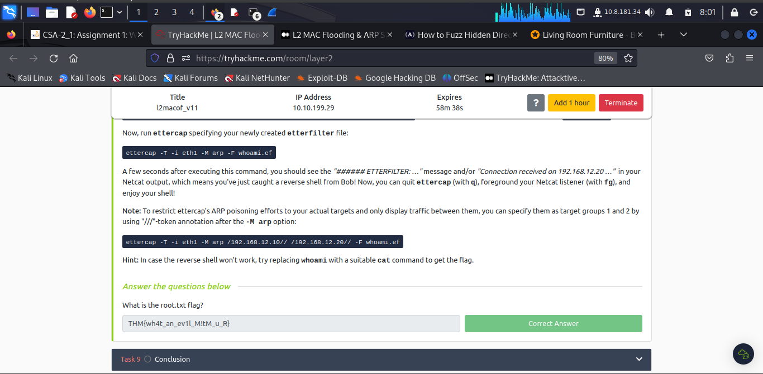

***Task 9: Conclusion***

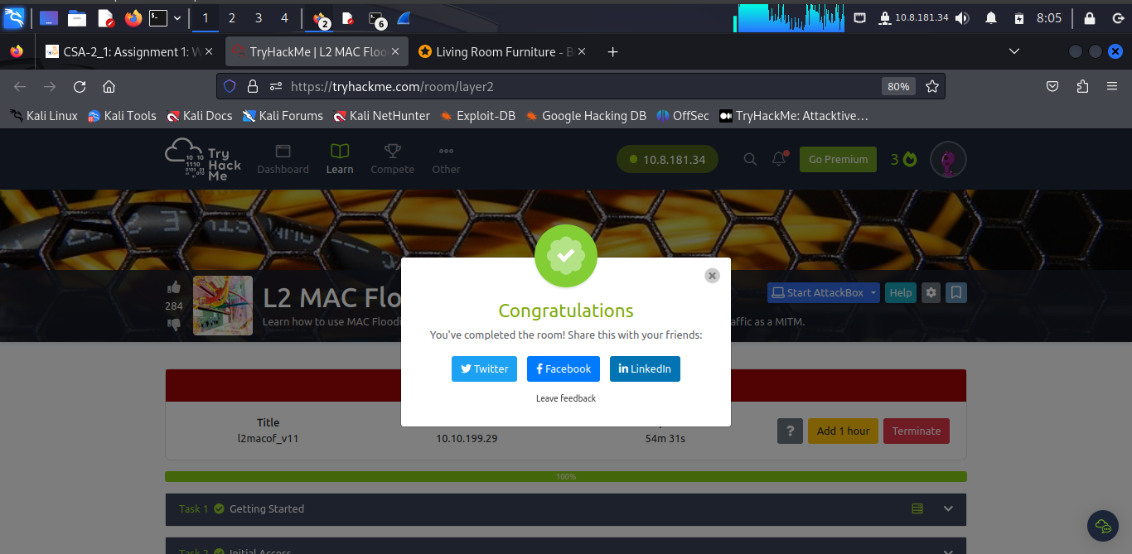

**Conclusion**

The learner navigated this room although a times facing difficulty in hostname location and the session provided a new perspective for network pentesting and gave a new *layer* of attacks for a ***toolbelt.***

Completion Link: <https://tryhackme.com/room/layer2>